1, 2, 3 Stages of Pointing and Shooting:
Key Strategies:

-- The player and team-mates helps decide which kind of throw and outcome is needed; and suggests possible landing zones,
--The player in circle visualizes the trajectory of ball to landing zone; visualizes the spot the boule will come to a stop and the desired outcome of the throw.
--The player throwing in the circle is not alone, but should be helped with landing zone and resting zone selection and verbally encouraged by the team.
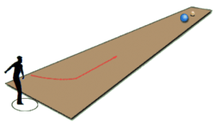
1. ROLLING POINT
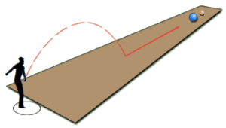
2. HALF LOB POINT
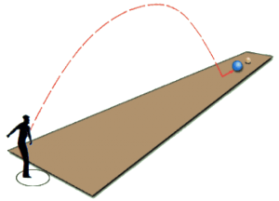
3. HIGH LOB POINT (advanced)

Shooting:

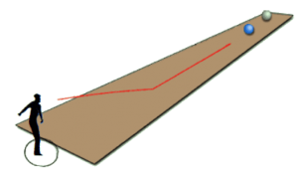
1. ROLLING SHOOTING

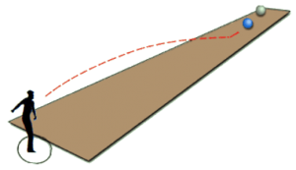
2. IN FRONT SHOOTING (Landing zone closer and closer to target boule. Good for pointing and giving closest boule a push)

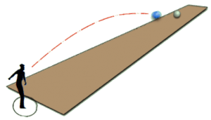
3. ON THE BOULE SHOOTING (Au Fer/ Carreau) Landing zone right in front of target boule.

