RULES OF THE GAME OF PETANQUE
The aim of the game is to place one’s boules closer to the “jack” [“but” or “cochonnet” in French] than those of one’s opponent.
The first team that reaches a total of 13 points after several “ends” [“mènes” in French] wins the game.

This game is played by 1 player against 1 player, or by 2 teams of either 2 or 3 players.
• Singles: 1 against 1 with 3 boules each.
• Doubles: 2 against 2 with 3 boules each.
• Triples: 3 against 3 with 2 boules each. There must not be more than 12 boules on the pitch.
This game is played with 100% steel boules and a small hardwood ball called a “jack”, which are thrown from inside a 50cm diameter circle that is either placed or drawn on the ground. Lots are drawn or a coin is tossed to decide which teams starts to play. Any player of this team chooses the starting point and stands inside the circle. While he is playing, the player’s feet must not go outside the circle before his boule reaches the ground. This player starts by throwing the jack to a distance between 6 and 10 m. The jack must stop at least 1m from any obstacle (such as a wall, tree, etc.). 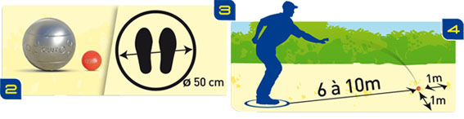
He then throws his first boule, trying to place it as close as possible to the jack.
A player from the second team then enters the circle and either “points”– that is, tries to place his boule closer to the jack than his opponent’s boule – or else “shoots” to knock away his opponent’s boule. The boule that is closer to the jack leads play.
If the second team’s player succeeds, then a player from the first team must play again. If he does not succeed, then the players from his own team play their boules until they take the lead or until they have no boules left to play.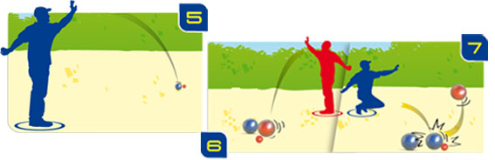 When one of the teams has no boules left to play, the players from the other team play their own remaining boules, trying to place them as well as possible.
When both teams have no boules left, the “end” is over and the points are counted. A team scores a point for every boule that it has placed closer to the jack than any of its opponent’s boules. 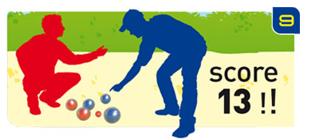
One of the players from the winning team then throws the jack from the point that it reached in the previous “end”, and the game continues until one of the teams scores 13 points.

